**Appendix**

African Wild Dog Dispersal and Connectivity under Climate Change - Lessons Learned from Seasonal Flood Extremes

David D. Hofmann1,2,§ Dominik M. Behr1,2 John W. McNutt2

Arpat Ozgul1,2 Gabriele Cozzi1,2

July 24, 2023

1. Department of Evolutionary Biology and Environmental Studies, University of Zurich,

Winterthurerstrasse 190, 8057 Zurich, Switzerland.

1. Botswana Predator Conservation Program, Wild Entrust, Private Bag 13, Maun,

Botswana.

§ Corresponding author (david.hofmann2@uzh.ch)

**Running Title:** African Wild Dog Dispersal in a Changing Climate: Lessons Learned from Seasonal Flood Extremes

**Keywords:** movement, connectivity, climate change, seasonality, dispersal, conservation, individual-based simulations, step-selection

# A.1 Dispersal Model

The model employed to simulate dispersal was based on an integrated step selection function (iSSF). In (integrated) step selection functions (iSSFs, Fortin et al., 2005; Avgar et al., 2016), observed GPS locations are converted into steps (the straight-line traveled between two GPS recordings (Turchin, 1998)) and compared to a set of *random* steps in a conditional logistic regression framework (Fortin et al., 2005; Thurfjell et al., 2014; Muff et al., 2020; Fieberg et al., 2021). The model presented in (Hofmann et al., 2023) used dispersal data collected on 16 dispersing AWDs from a free-ranging wild dog population in northern Botswana. GPS data during dispersal was collected at 4-hourly intervals and translated into steps of similar duration. Observed steps were then paired step with 24 random steps that were generated using a uniform distribution for turning angles (−*π,*+*π*) and step lengths from a gamma distribution fitted to observed steps (scale *θ* = 6’308 and shape *k* = 0.37). It was then assumed that animals assigned to each observed and random step a selection score of the form (Fortin et al., 2005):

*w*(*x*) = *exp*(*β*1*x*1 + *β*2*x*2 + *...* + *βnxn*) (Equation S1)

Where (*x*1*,x*2*,...,xn*) represent the covariate values along each of the steps and the (*β*1*,β*2*,...,βn*) are the animal’s relative selection strengths (Avgar et al., 2017) towards these covariates. The benefit of *integrated* SSFs over regular SSFs is that they provide a means to render two complementary “kernels”. A *movement* kernel that describes general movement behavior of dispersing AWDs and a *habitat* kernel that describes preferences of AWDs with regards to environmental conditions (Fieberg et al., 2021). iSSFs also allow interactions among the two kernels and are thus suitable to render that movement behavior may change depending on habitat conditions. A fitted iSSF model can be used as an individual-based movement model to simulate dispersal (Signer et al., 2017; Hofmann et al., 2023)

# A.2 Dispersal Model Estimates

Figure S1 depicts the model estimates from Hofmann et al. (2023) that we used to simulate dispersal trajectories in this study.

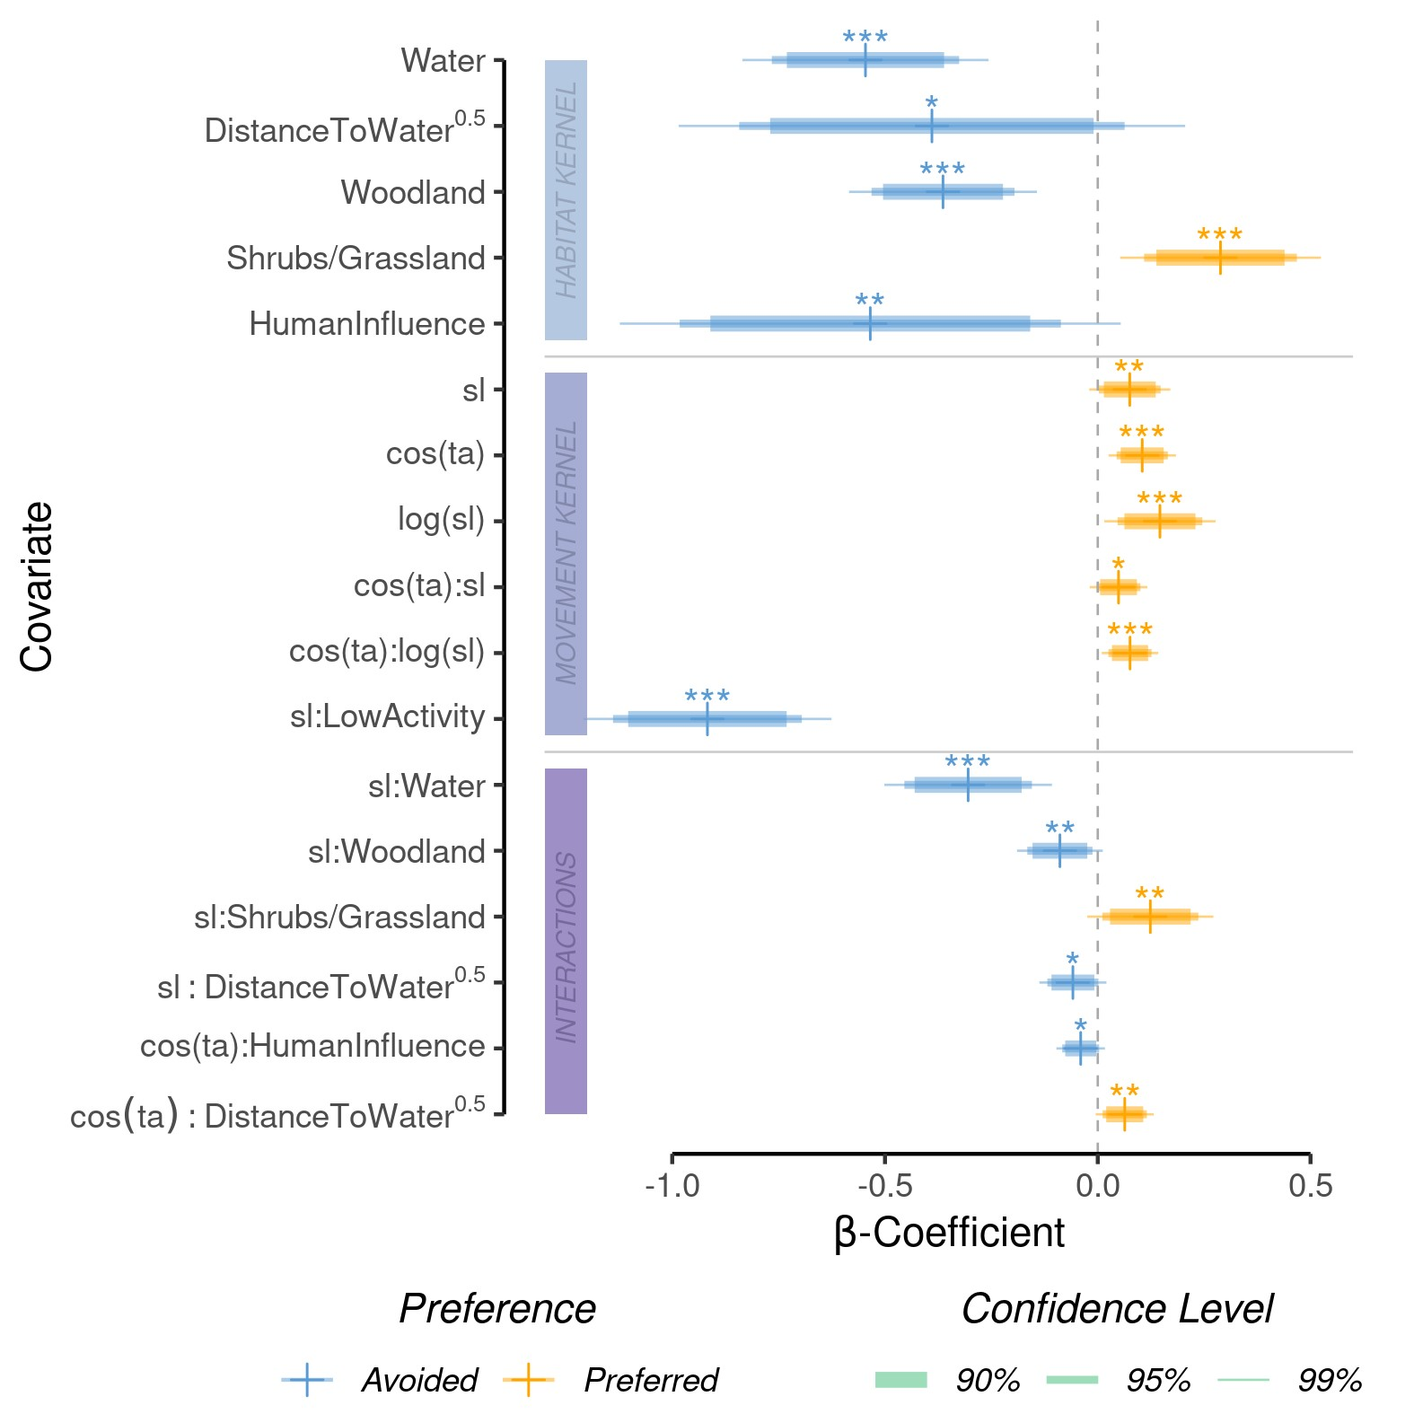

**Figure S1:** Model parameters from the step-selection model implemented by Hofmann et al. (2023). The model was fit to GPS data of dispersing African wild dogs and comprises of a habitat kernel (light blue band), a movement kernel (dark blue band), and their interactions (purple band). Abbreviations are as follows: sl = step-length, log(sl) = natural logarithm of the step-length, cos(ta) = cosine of the relative turning angle.

# A.3 Source-Specific Inter-Patch Connectivity

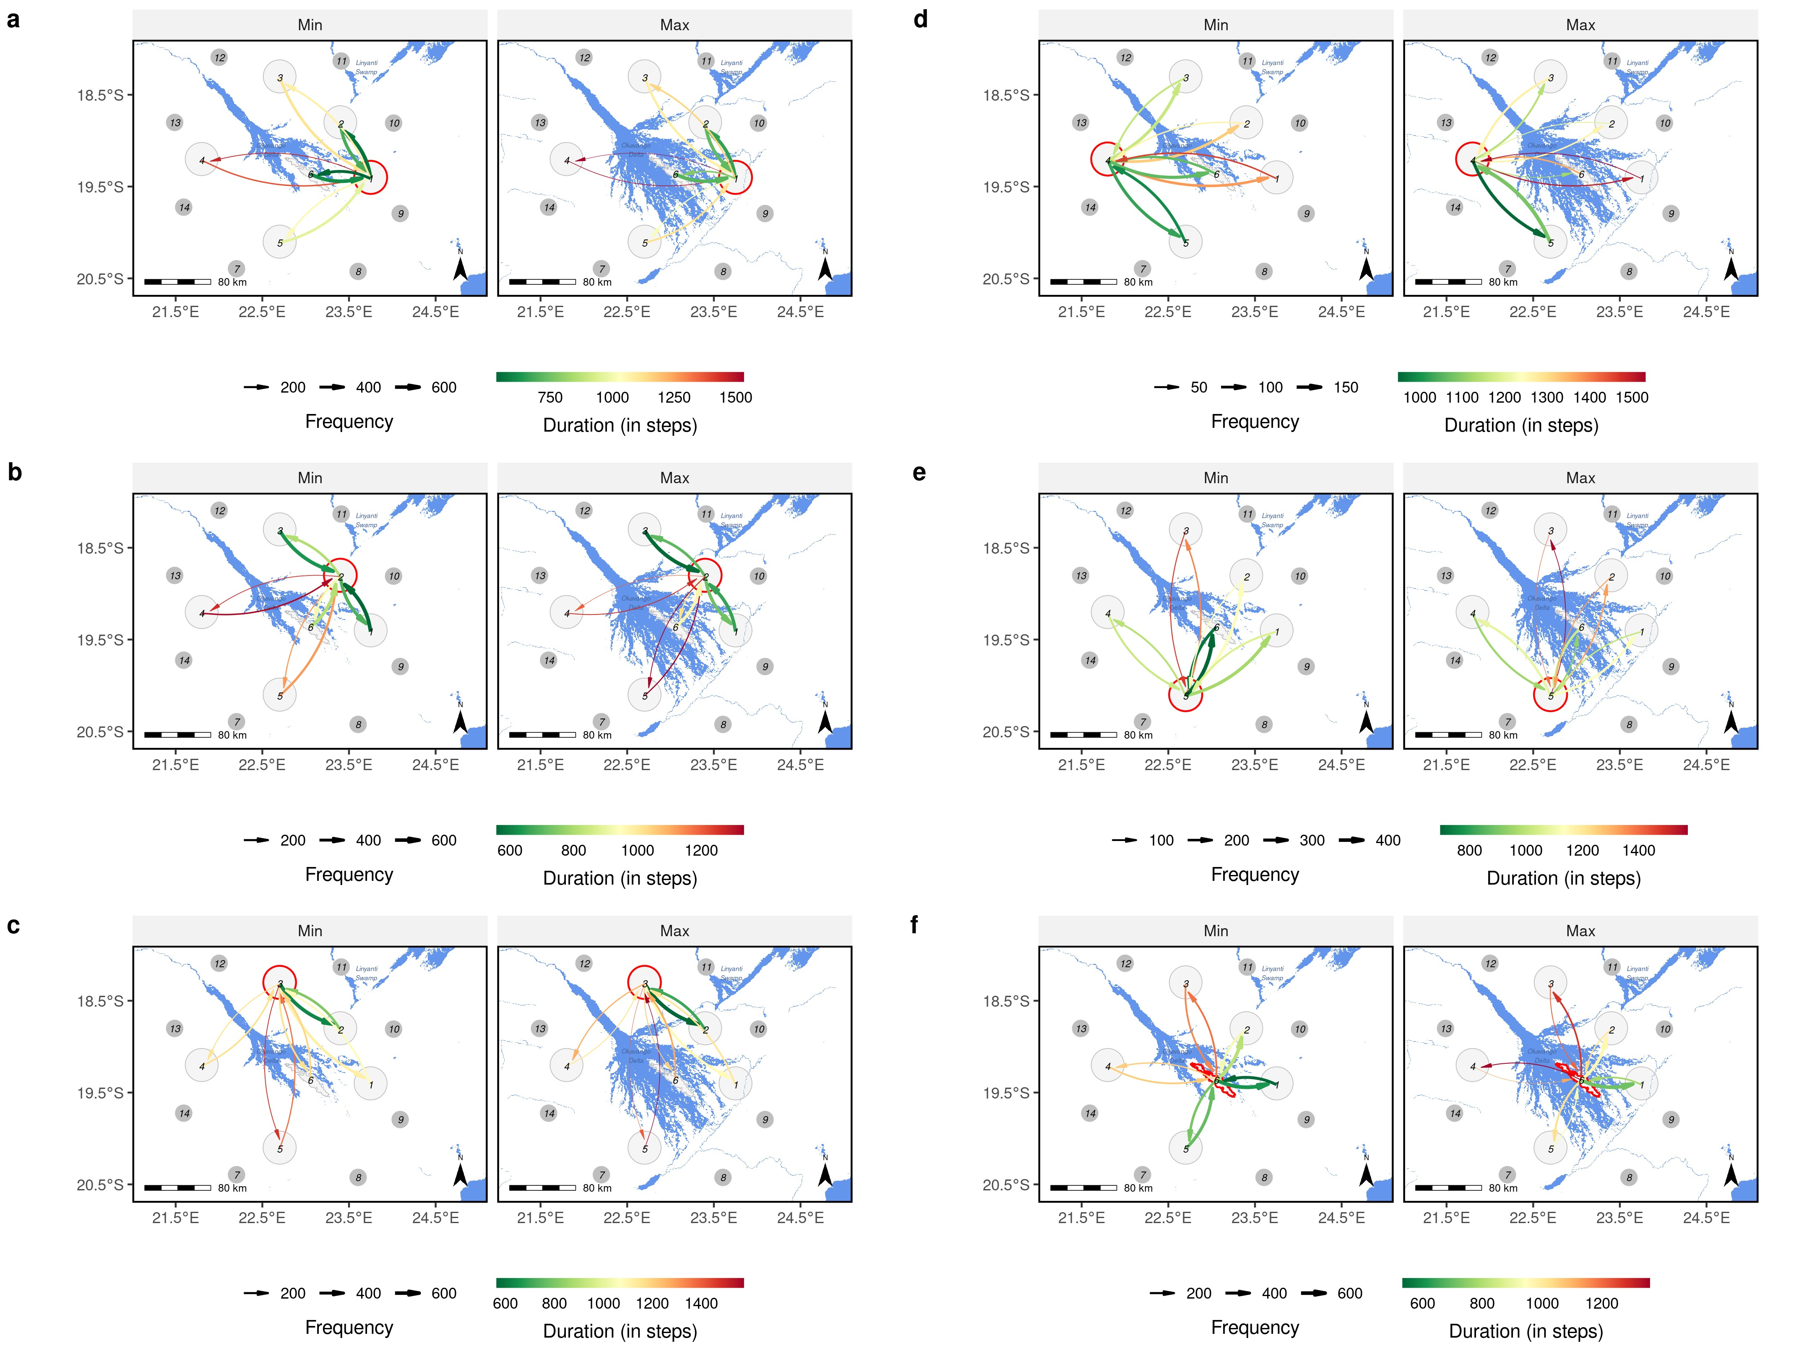

**Figure S2:** Spatial representation of inter-patch connectivity derived for each source area separately across the two extreme flood-scenarios. The focal source area of each subfigure is highlighted by a red circle. Subfigure (a), for instance, depicts inter-patch connectivity for source area 1.

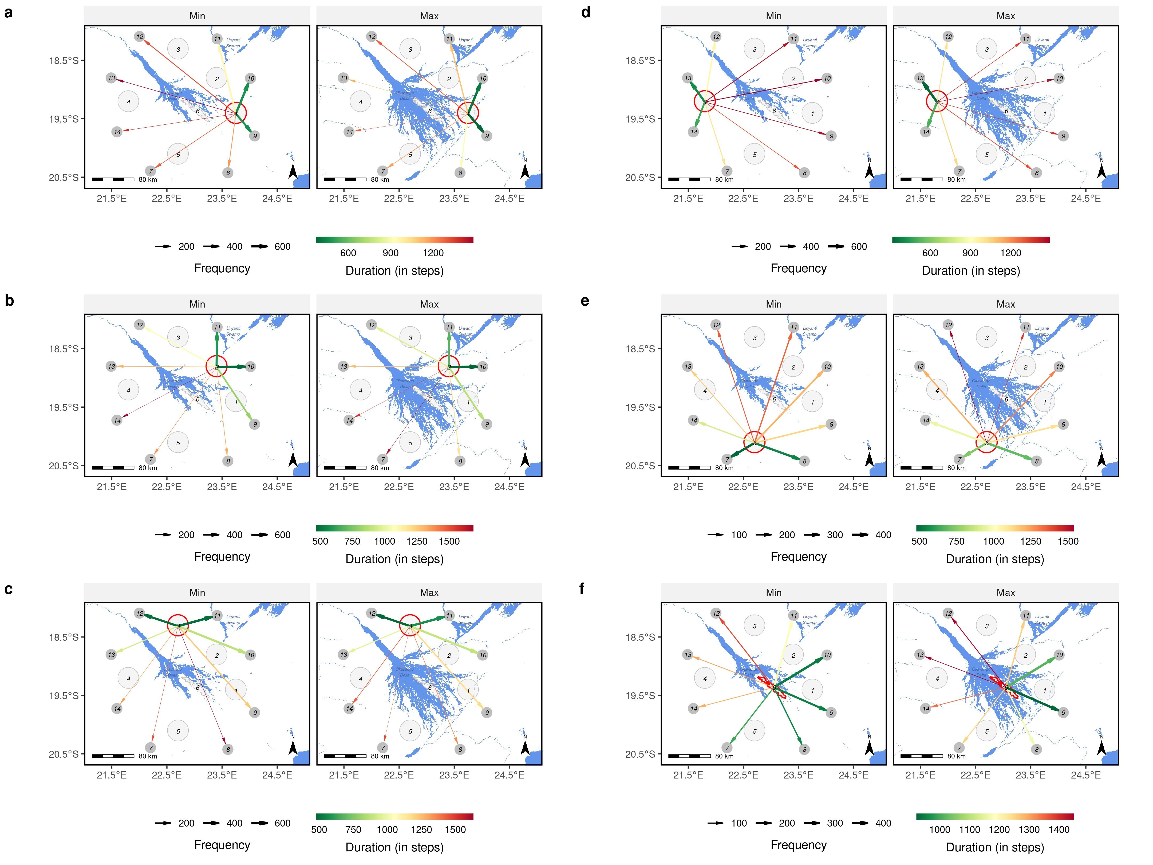

**Figure S3:** Spatial representation of emigration patterns derived for each source area separately across the two extreme flood-scenarios. The focal source area of each subfigure is highlighted by a red circle. Subfigure (a), for instance, depicts the number of emigrating individuals from source area 1.

# A.4 Source-Specific Heatmaps

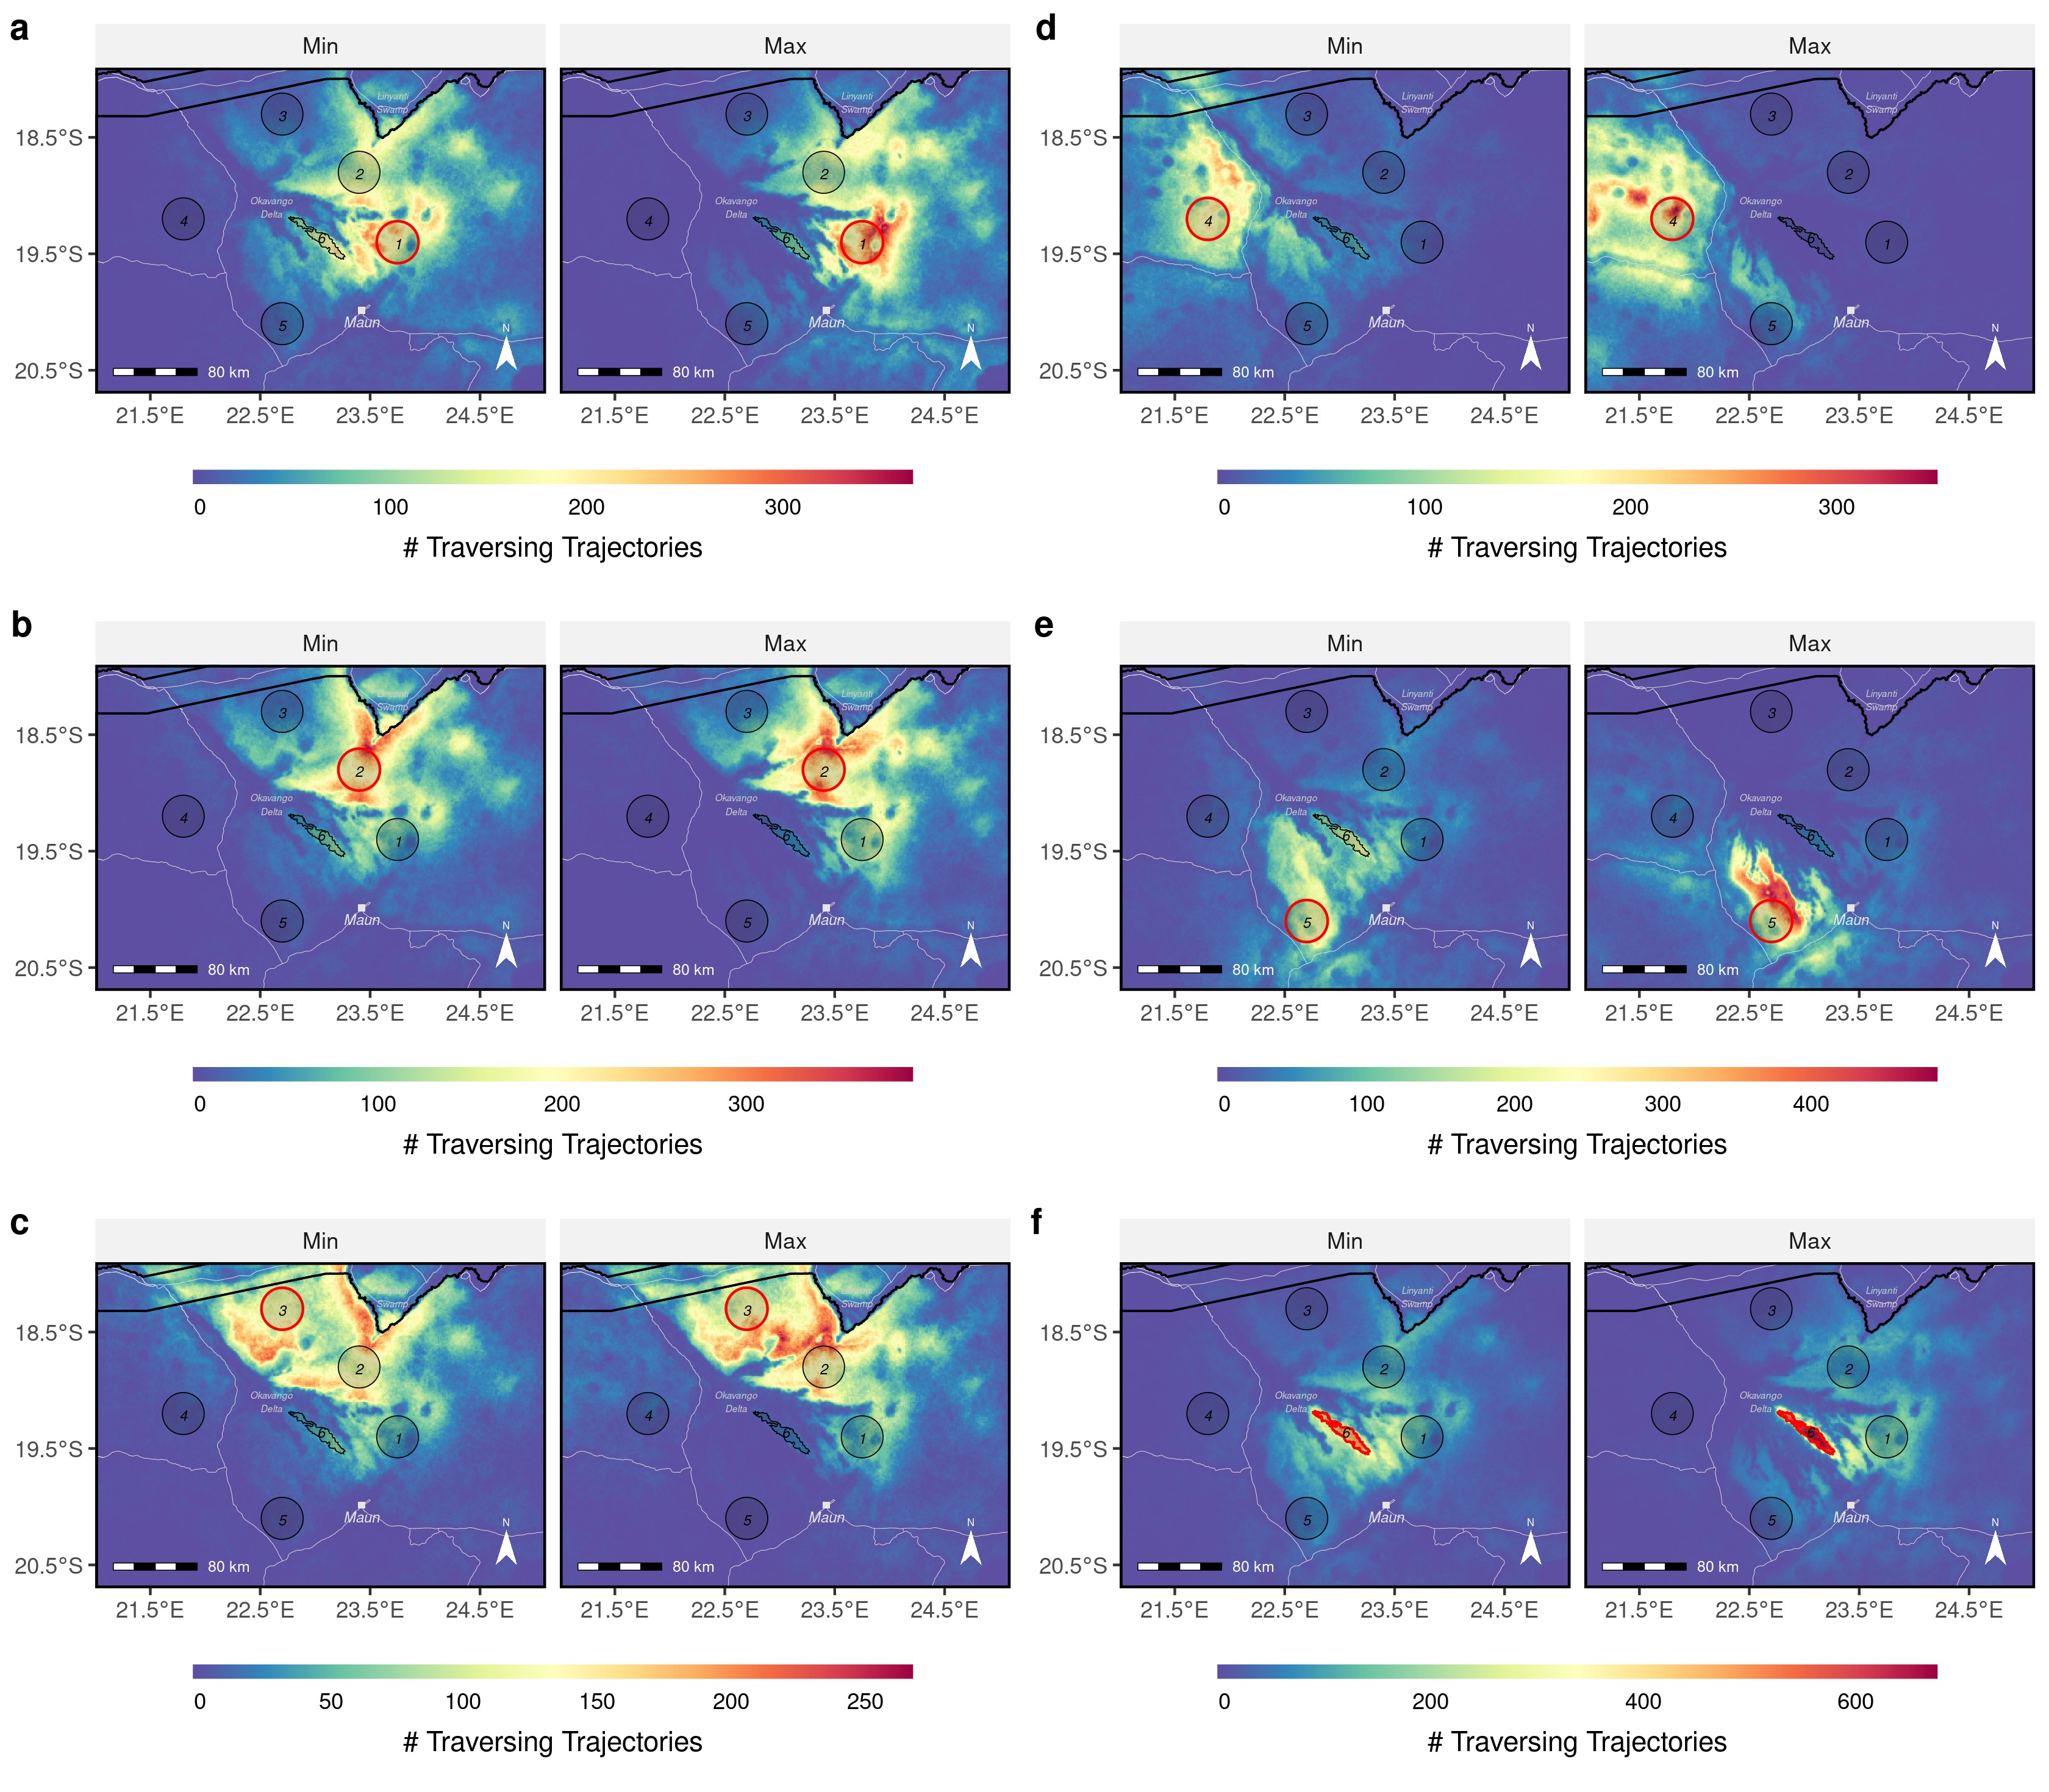

**Figure S4:** Heatmaps prepared for each source area separately across the two extreme floodscenarios. The focal source area of each subfigure is highlighted by a red circle. Subfigure (a), for instance, depicts the heatmaps for source area 1.

# A.5 Source-Specific Betweenness

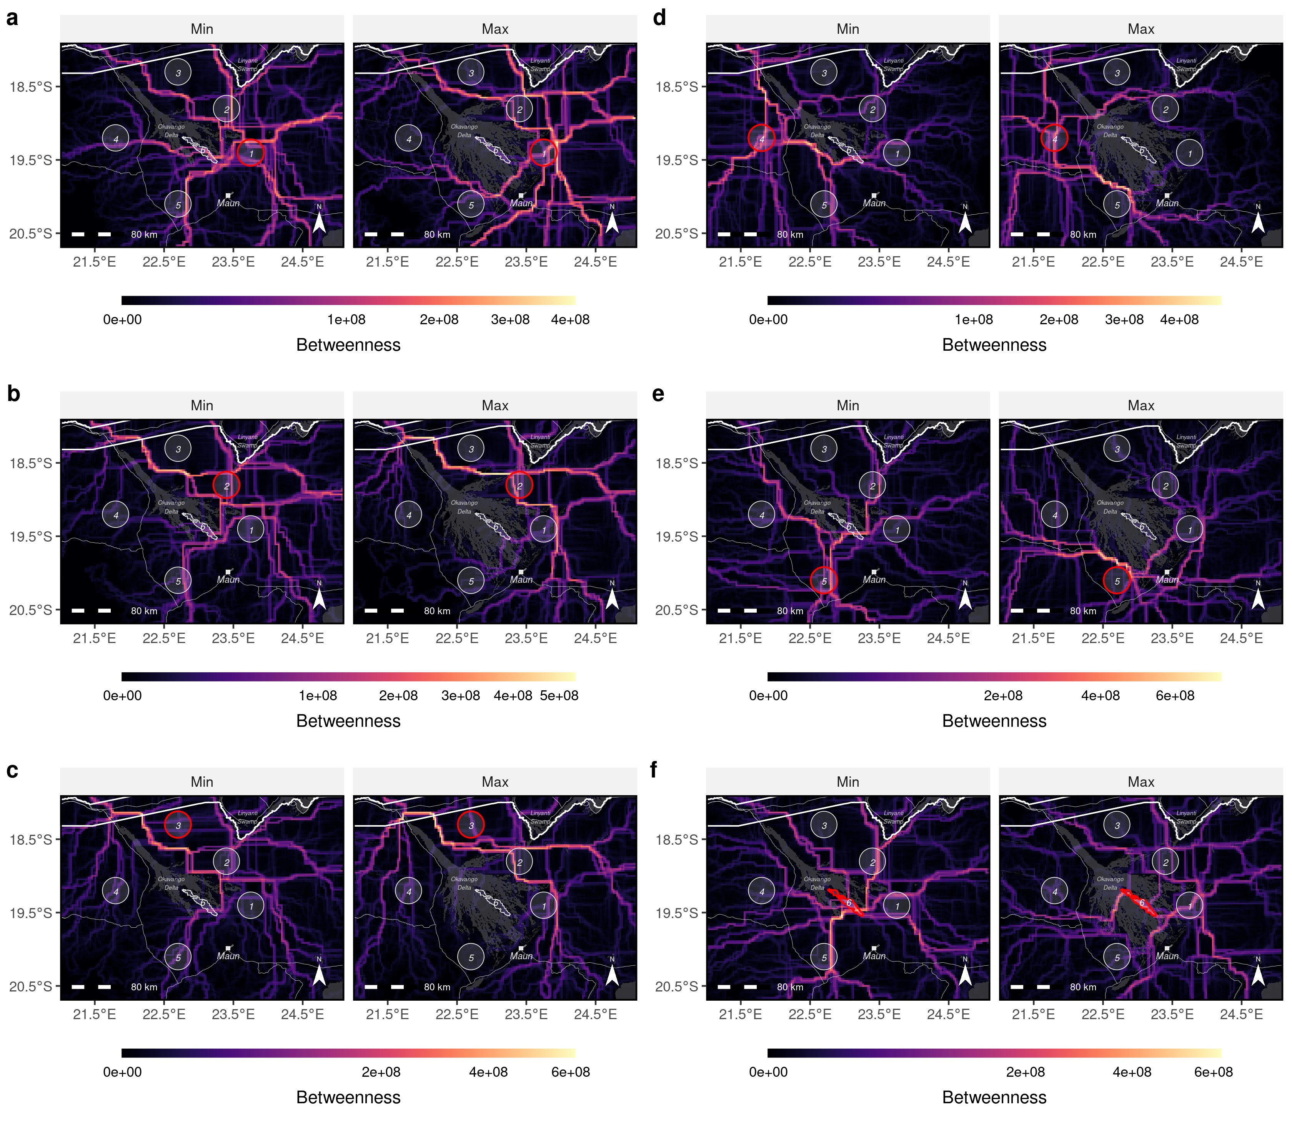

**Figure S5:** Betweenness maps prepared for each source area separately across the two extreme flood-scenarios. The focal source area of each subfigure is highlighted by a red circle. Subfigure (a), for instance, depicts the betweenness maps for source area 1.

# A.6 Source-Specific Human Wildlife Conflict

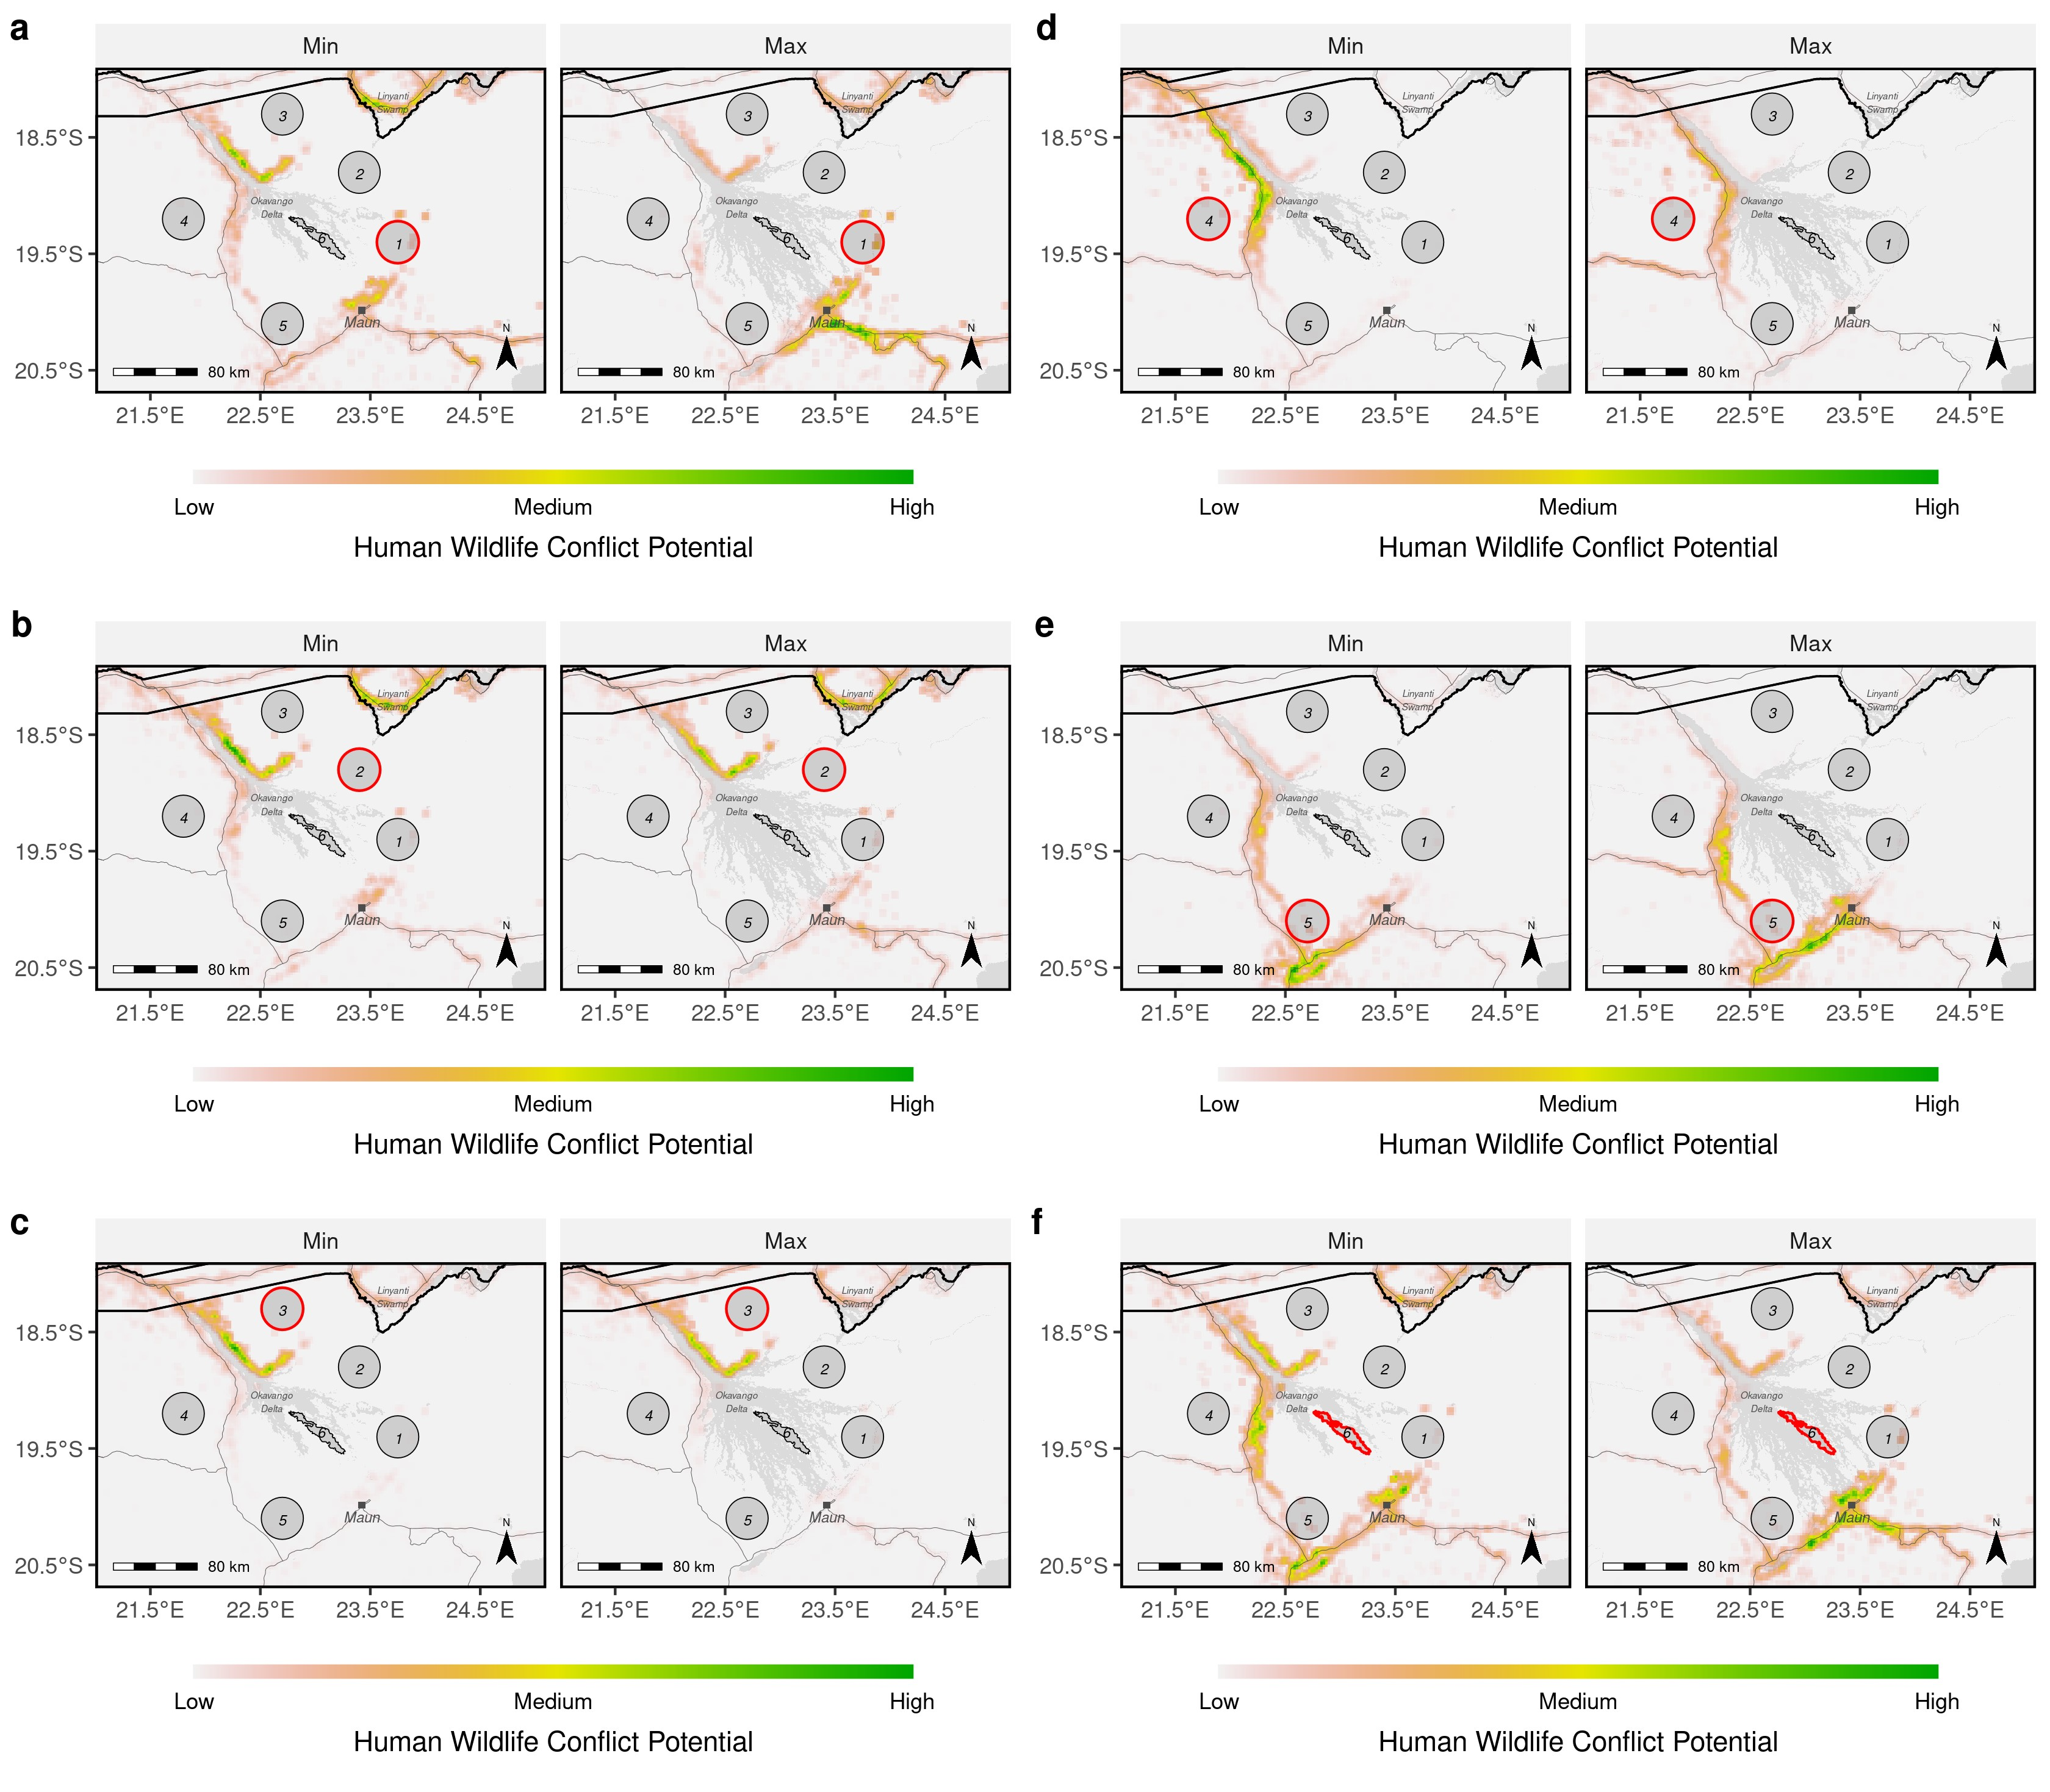

**Figure S6:** Human wildlife conflict maps prepared for each source area separately across the two extreme flood-scenarios. The focal source area of each subfigure is highlighted by a red circle. Subfigure (a), for instance, depicts the human wildlife conflict maps for source area 1.

# A.7 Changes in Human Wildlife Conflict Potential

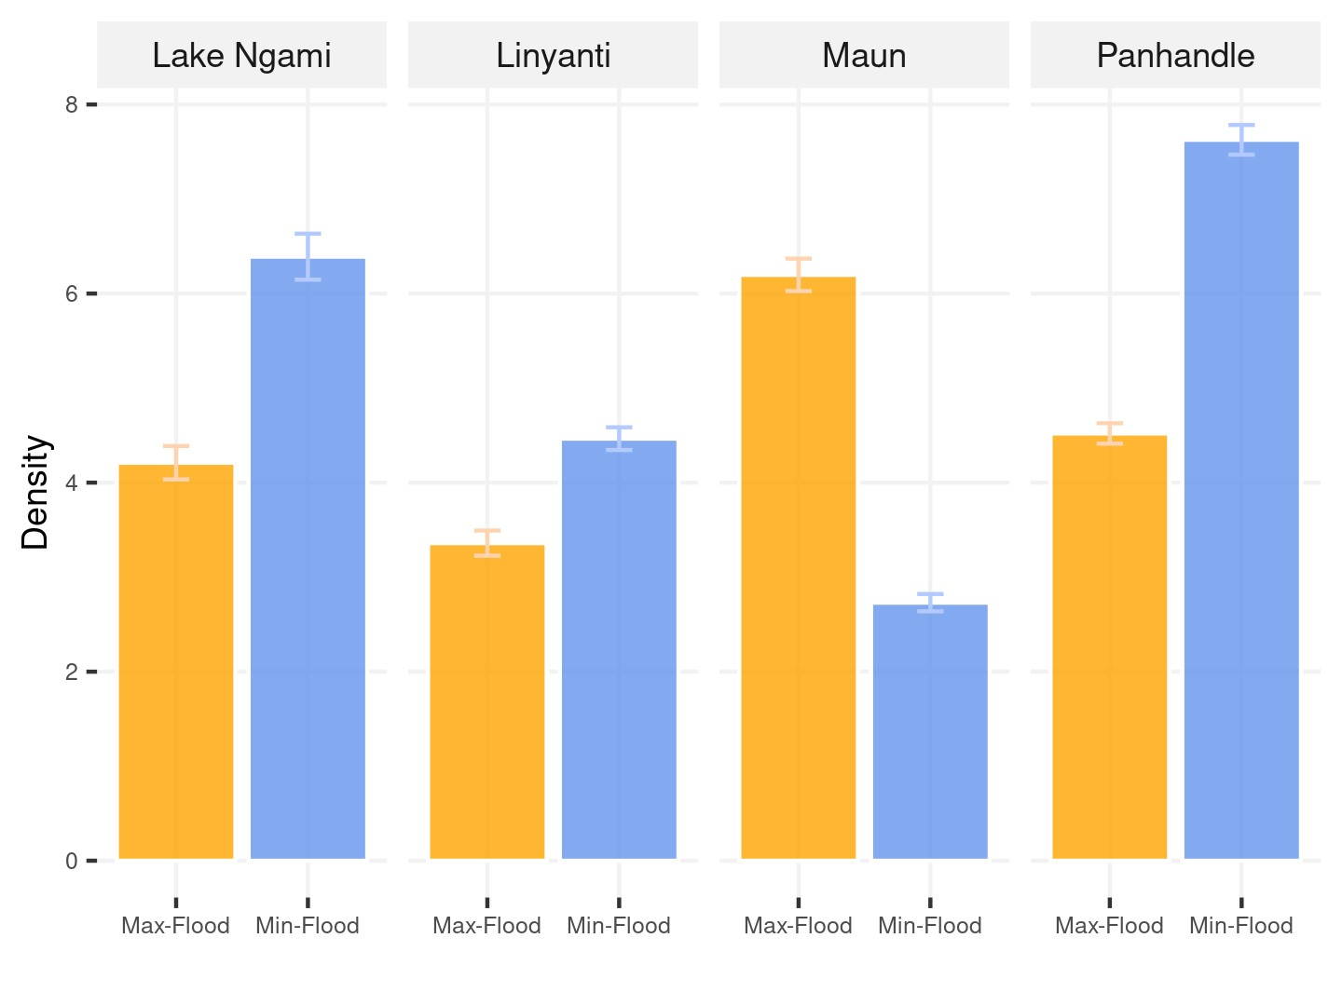

**Figure S7:** Number of simulated trajectories within the vicinity of human-dominated landcapes in different areas of interest across the minimum and maximum flood scenarios.

# References

Avgar, T., Lele, S. R., Keim, J. L., and Boyce, M. S. (2017). Relative Selection Strength: Quantifying Effect Size in Habitat- and Step-Selection Inference. *Ecology and Evolution*, 7(14):5322–5330.

Avgar, T., Potts, J. R., Lewis, M. A., and Boyce, M. S. (2016). Integrated Step Selection Analysis: Bridging the Gap Between Resource Selection and Animal Movement. *Methods in Ecology and Evolution*, 7(5):619–630.

Fieberg, J., Signer, J., Smith, B., and Avgar, T. (2021). A ‘How to’ Guide for Interpreting Parameters in Habitat-Selection Analyses. *Journal of Animal Ecology*, 90(5):1027–1043.

Fortin, D., Beyer, H. L., Boyce, M. S., Smith, D. W., Duchesne, T., and Mao, J. S. (2005). Wolves Influence Elk Movements: Behavior Shapes a Trophic Cascade in Yellowstone National Park. *Ecology*, 86(5):1320–1330.

Hofmann, D. D., Cozzi, G., McNutt, J. W., Ozgul, A., and Behr, D. M. (2023). A ThreeStep Approach for Assessing Landscape Connectivity Via Simulated Dispersal: African Wild Dog Case Study. *Landscape Ecology*.

Muff, S., Signer, J., and Fieberg, J. (2020). Accounting for Individual-Specific Variation in Habitat-Selection Studies: Efficient Estimation of Mixed-Effects Models Using Bayesian or Frequentist Computation. *Journal of Animal Ecology*, 89(1):80–92.

Signer, J., Fieberg, J., and Avgar, T. (2017). Estimating Utilization Distributions from Fitted Step-Selection Functions. *Ecosphere*, 8(4):e01771.

Thurfjell, H., Ciuti, S., and Boyce, M. S. (2014). Applications of Step-Selection Functions in Ecology and Conservation. *Movement Ecology*, 2(4).

Turchin, P. (1998). *Quantitative Analysis of Movement: Measuring and Modeling Population Redistribution in Animals and Plants*. Sinauer Associates, Sunderland, Mass.